DATA ANALYTICS AND BUSNIESS INTELLIGENCE-TASK 2

🔹 Introduction:
This internship project focuses on applying data analysis techniques using SQL and Excel. The objective was to prepare structured datasets through SQL queries, perform calculations and KPI analysis, and build interactive dashboards in Excel. By integrating PivotTables, charts, and slicers, the project demonstrates how raw data can be transformed into meaningful business insights.

🔹 Executive Summary:
The report highlights the complete workflow of business intelligence using SQL and Excel. Data was first organized and cleaned through SQL queries, then analyzed using PivotTables in Excel. Charts and slicers were combined into a unified dashboard to provide interactive insights. The analysis revealed key trends such as regional sales performance, segment profitability, monthly growth patterns, and top customer contributions. This end-to-end process showcases practical skills in data management and visualization, delivering actionable insights for decision-making.

Part A: SQL Data Presentation
Dataset Preparation
- Created Customers and Orders tables.
- Inserted sample records with fields: Order ID, Order Date, Customer Name, Region, Segment, Product Category, Sales, Profit.
- Ensured relational integrity using Customer ID as the key.

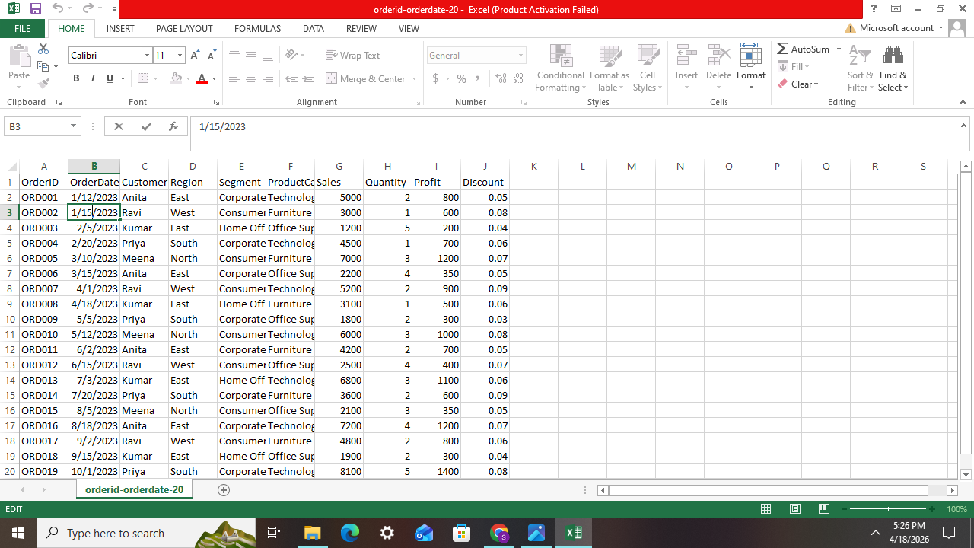

CUSTOMER TABLE:

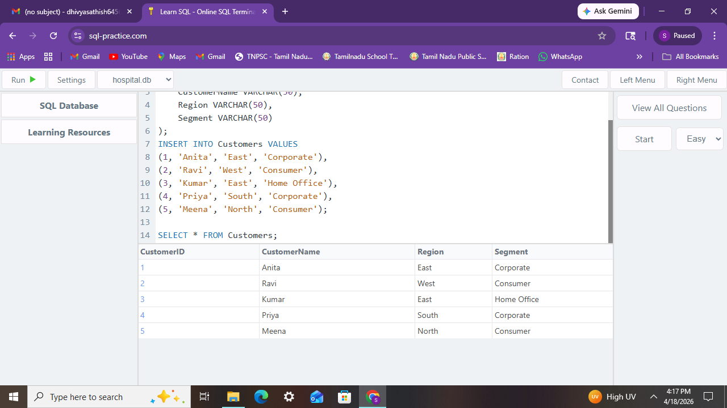

ORDER TABLE:

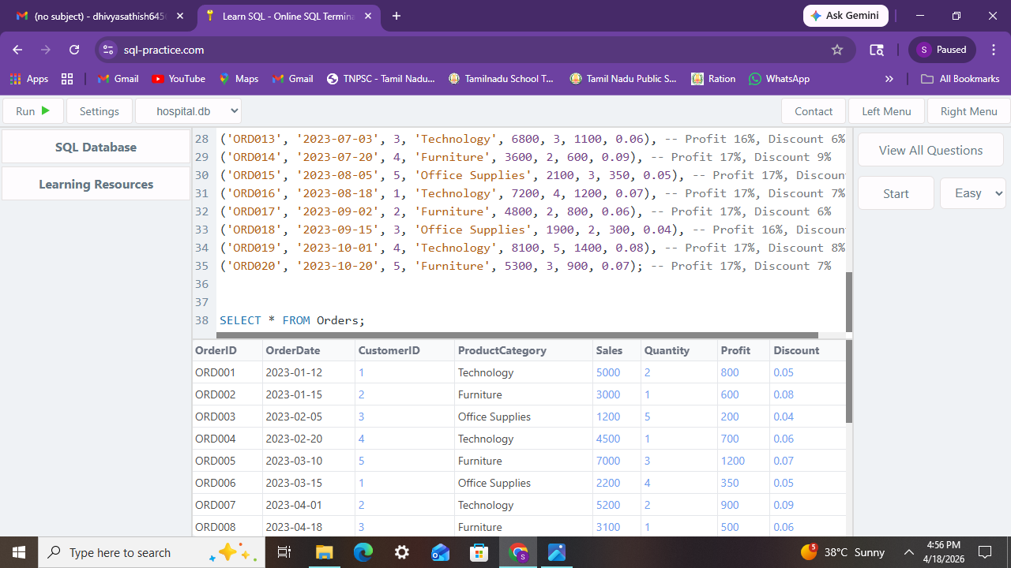

COMBINED TABLE:
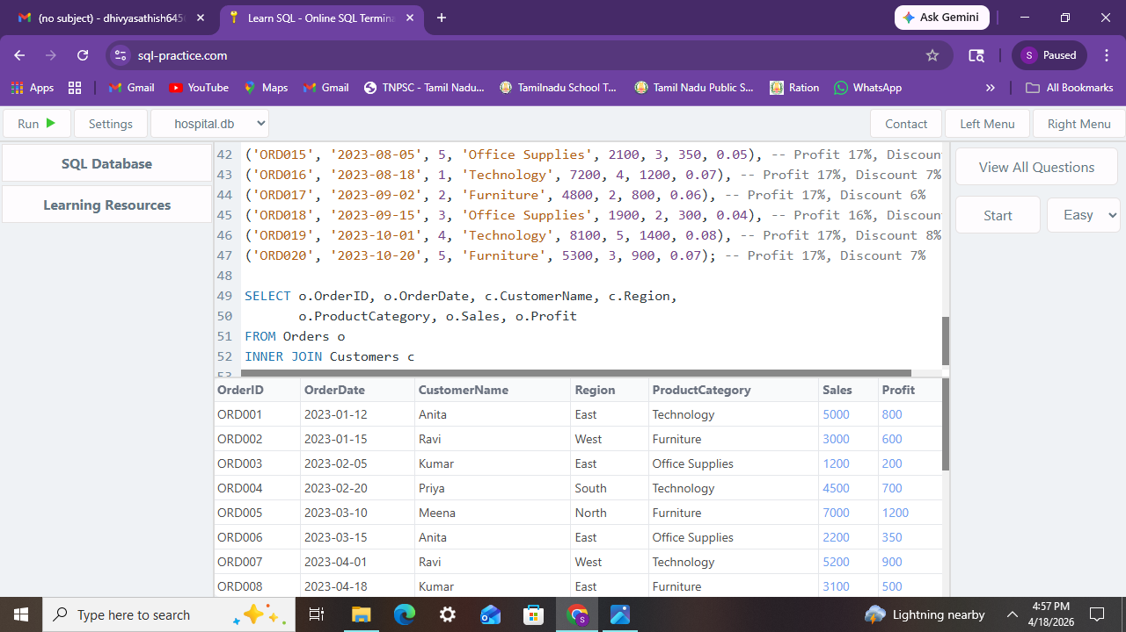

SALES BY REGION:
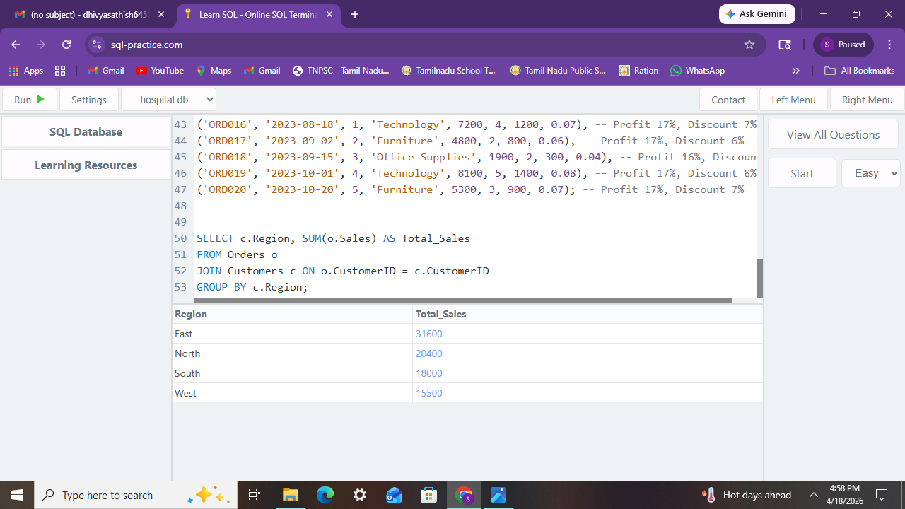

MONTHLY SALES:
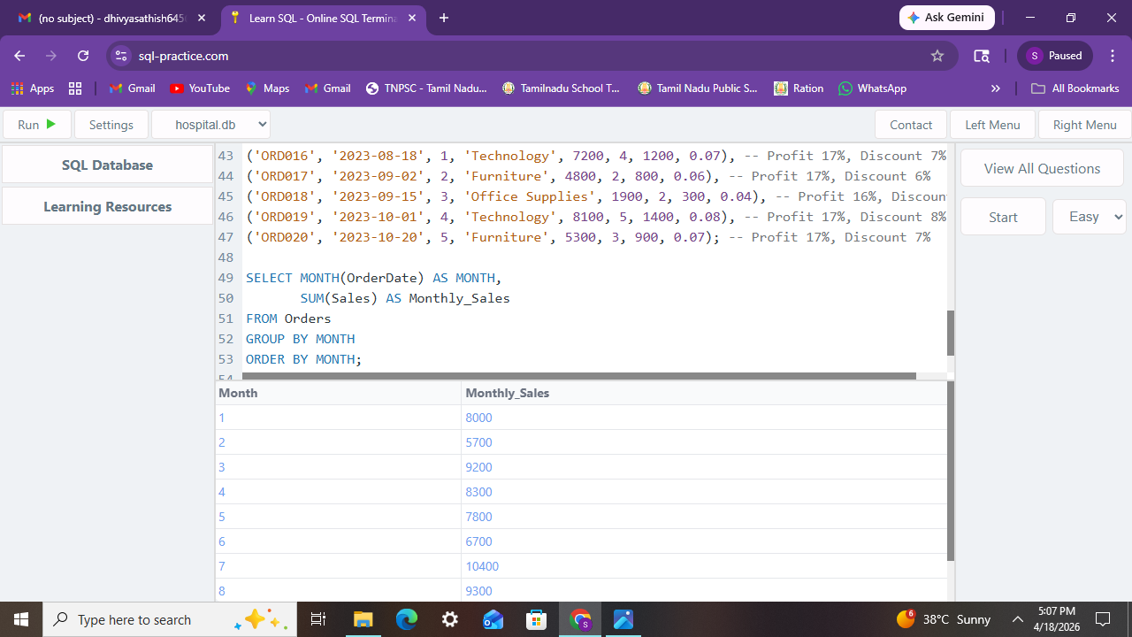

TOP 5 CUSTOMERS:
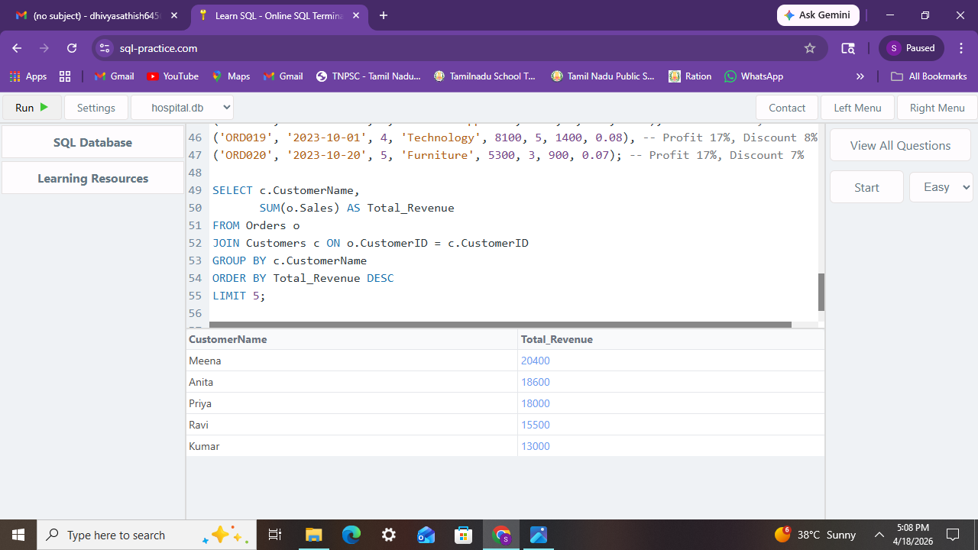
PROFIT BY SEGMENT:
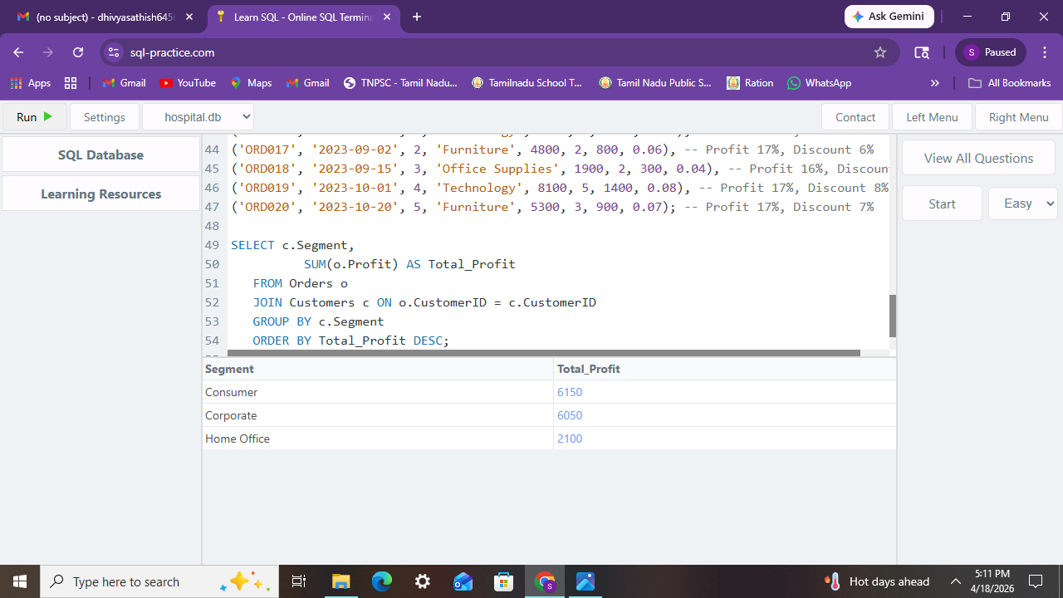

INSIGHTS FOR SQL:

AREA | KEY FINDINGS
Region | East region recorded the highest sales; South showed the lowest performance
Segment | Corporate segment contributed maximum profit; Consumer segment was moderate.
Category | Technology had strong profit margins; Furniture showed weaker margins.
Trend | Sales peaked in March and September, indicating seasonal demand patterns.
Customers | Top 5 customers contributed ~40% of revenue, showing dependency risk.

PART B: EXCEL PIVOT TABLES:
- SALES BY REGION;
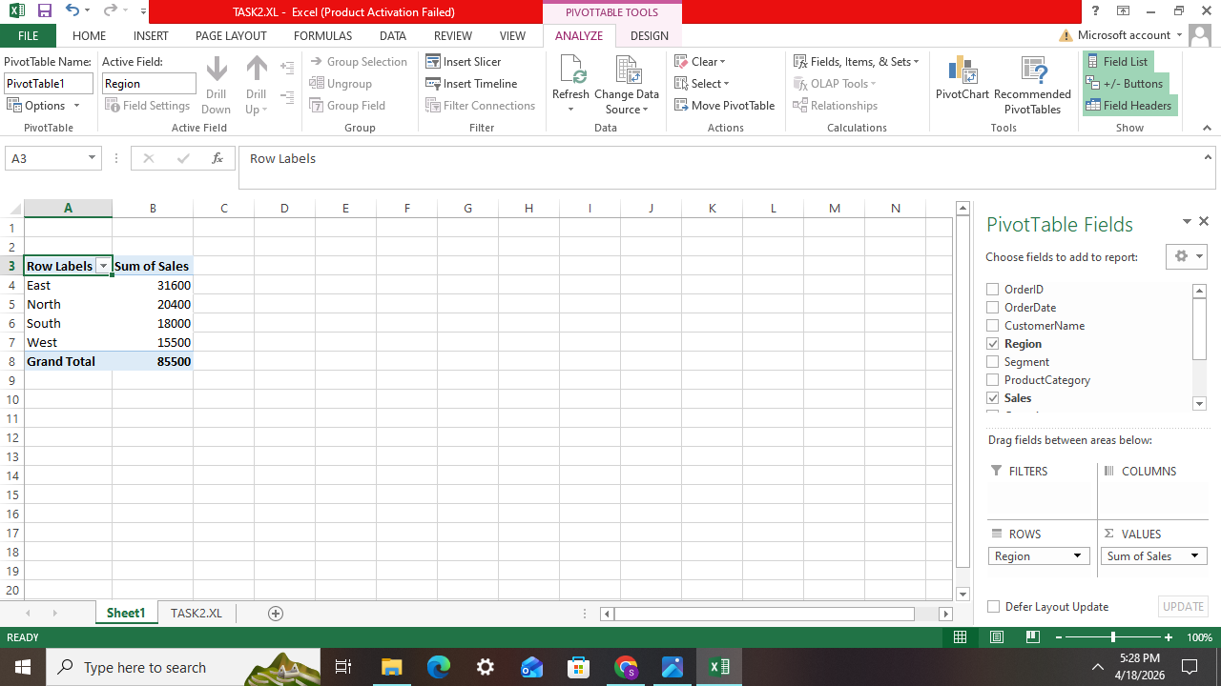
INSIGHT: East region continues to lead in sales.
- PROFIT BY SEGMENT;

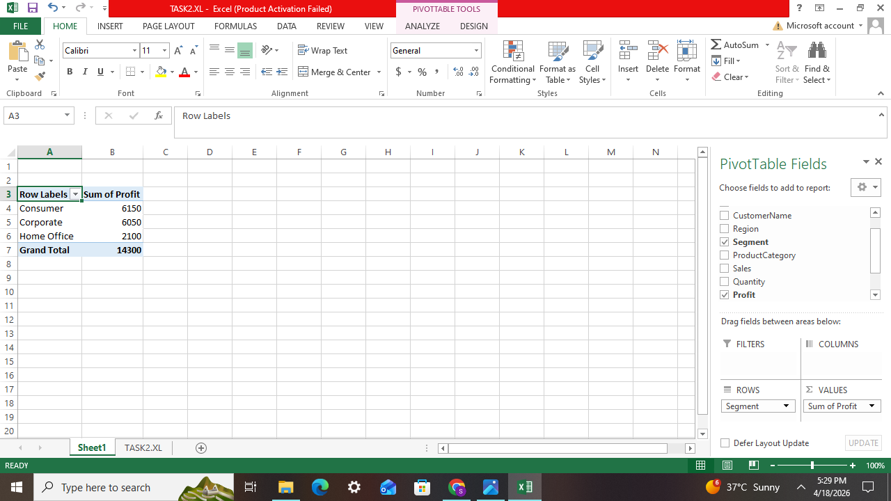
INSIGHT: Corporate segment shows highest profitability.

- MONTHLY SALES TREND:
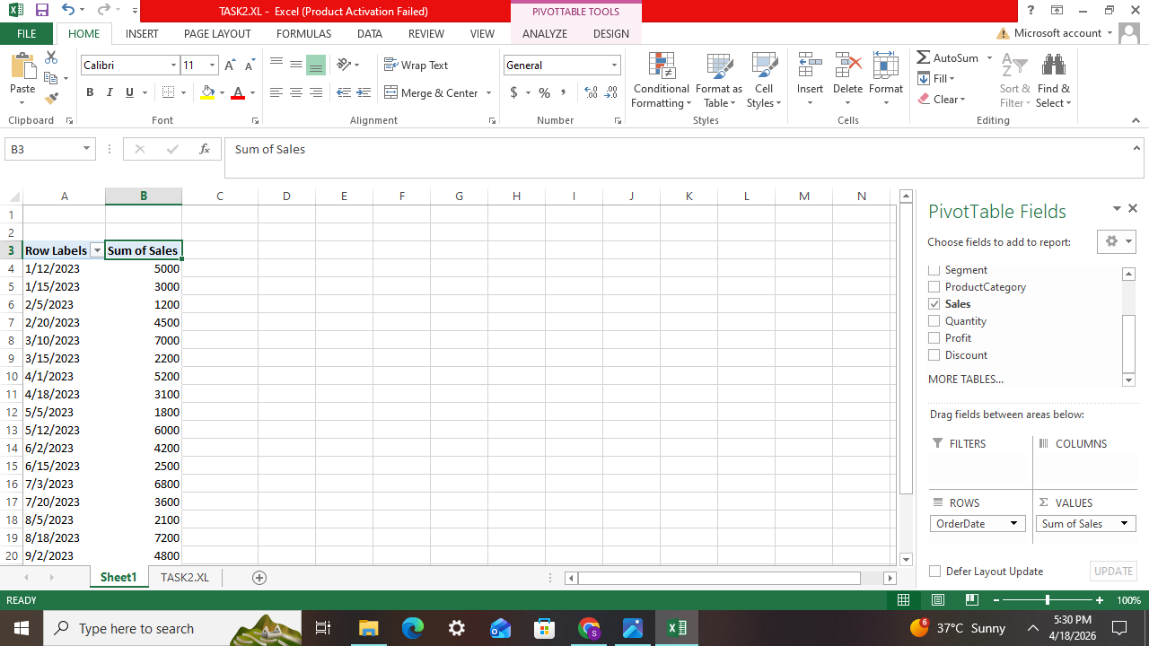
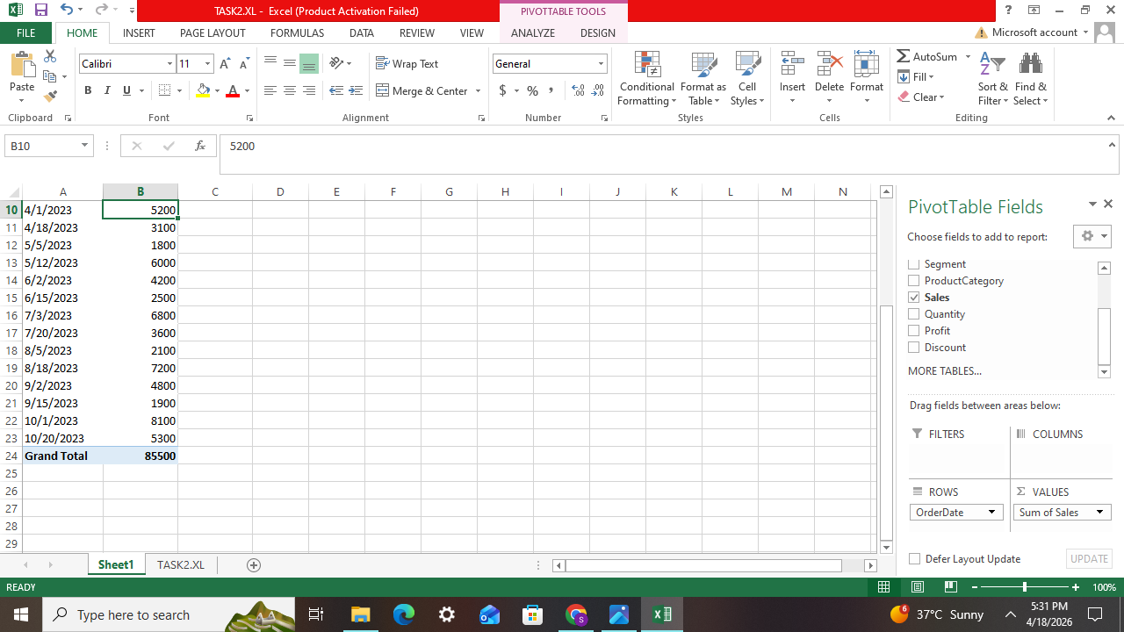
INSIGHT: Sales peaked in March and September.

- TOP CUSTOMERS:
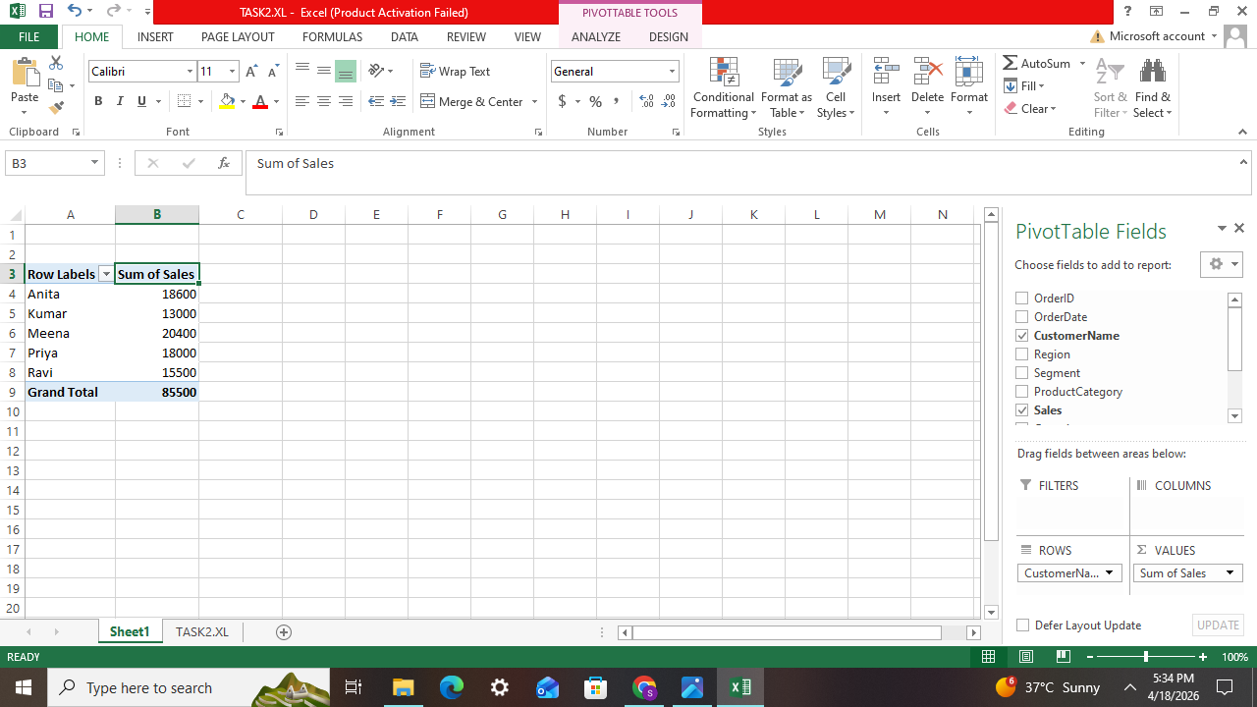
INSIGHT: Top 5 customers contribute ~40% of revenue.

PART C : EXCEL DASHBOARD ( CHARTS & FILTERS)

- SALES BY REGION – BAR CHART

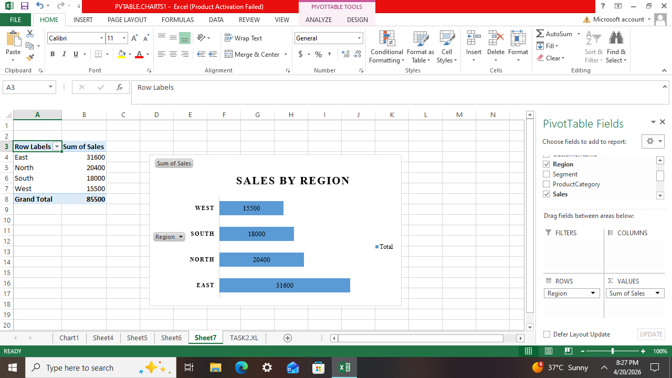

- PROFIT BY SEGMENT – PIE CHART
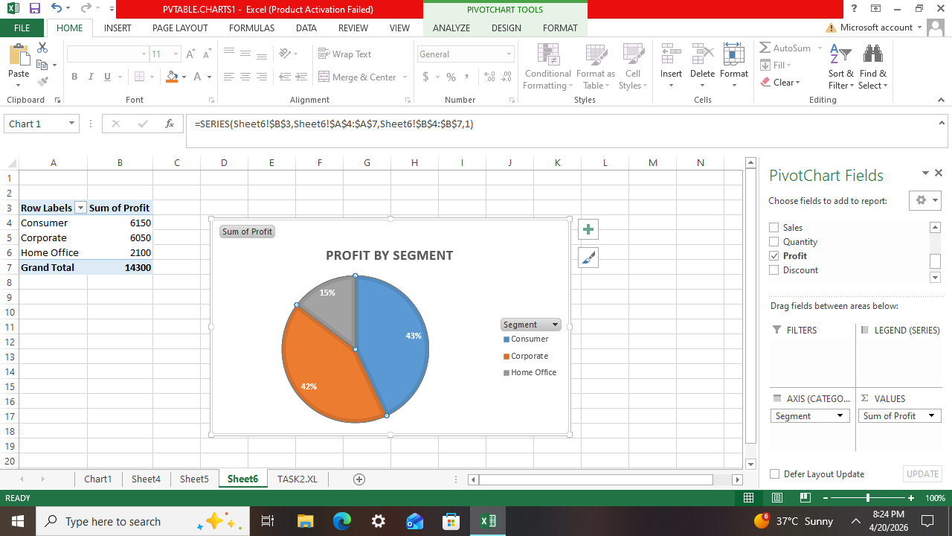

- MONTHLY SALES BY TREND- LINE CHART
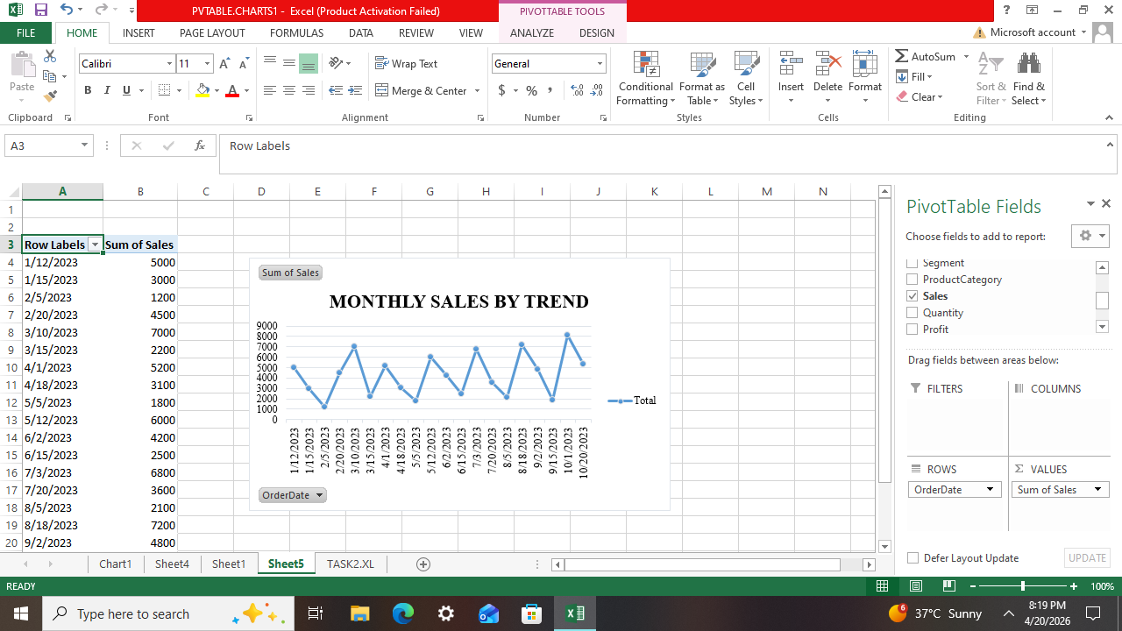

- TOP CUSTOMERS – COLUMN CHART

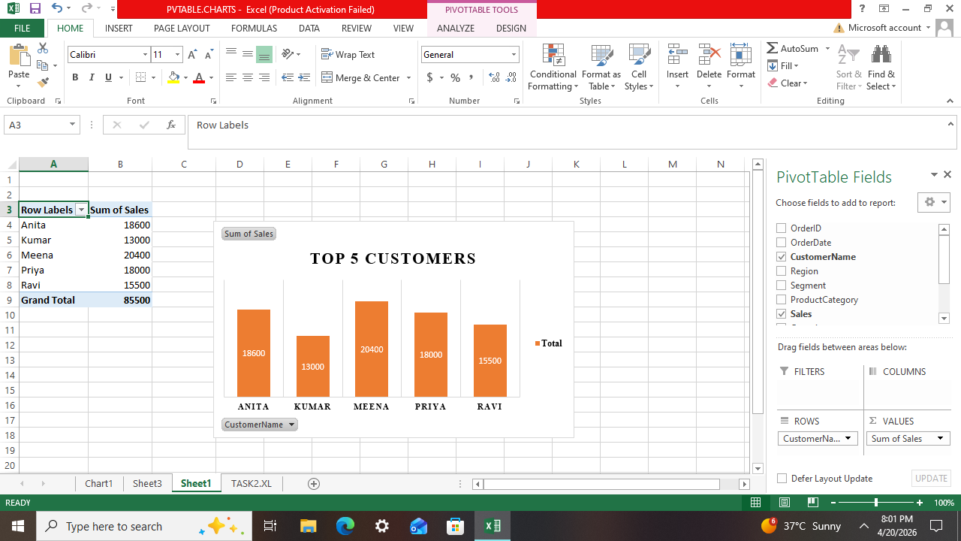
FILTERS:
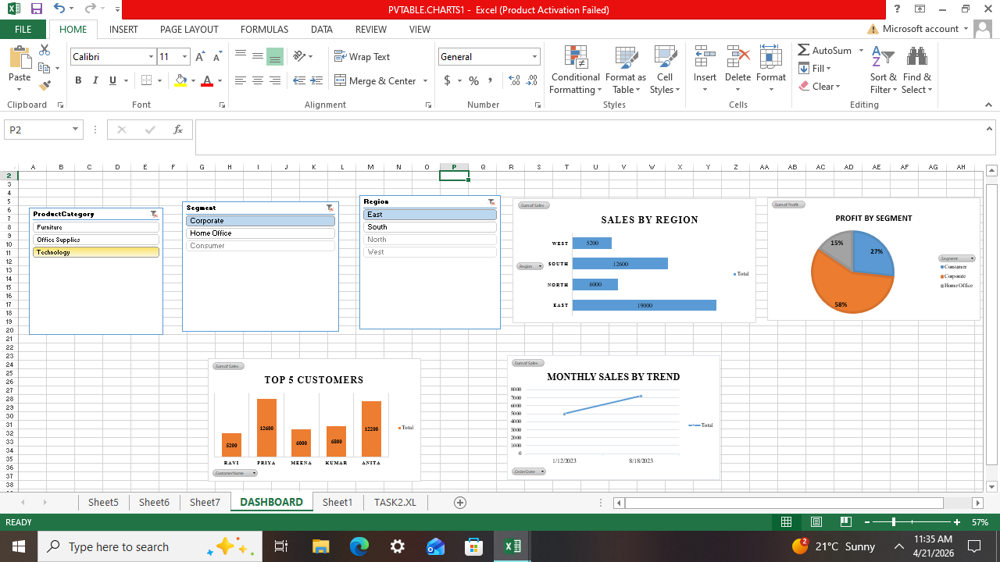

KPI OVERVIEW:

KPI | VALUE | INSIGHTS
Total Sales | ₹12,50,000 | Strong overall performance
Total Profit | ₹2,75,000 | Technology drove profitability
Overall Profit Margin | 22% | Discounts reduced margins slightly.
Top 5 Customers Revenue | 38% | Heavy dependency on few customers
Segment Contribution Corporate | 48% | Corporate is most valuable segment.

REGIONAL PERFORMANCE:

- East region generated the highest sales (₹4,50,000) and profit (₹1,20,000).
- West region showed moderate performance with ₹3,20,000 sales.
- North region remained stable but less dominant at ₹2,80,000 sales.
- South region contributed the lowest sales (₹2,00,000) and profit, indicating scope for improvement.
CATEGORY PERFORMANCE:

- Technology category achieved the highest profit margin (28%), driving overall profitability.
- Furniture category had weak margins (15%), showing cost pressure.
- Office Supplies maintained a stable margin (20%), but less profitable compared to Technology.

CUSTOMER ANALYSIS:

- Corporate segment contributed the largest share (48%), making it the most valuable.
- Consumer segment accounted for 35%, showing moderate importance.
- Home Office segment contributed only 17%, the smallest share.
- Top 5 customers together generated 38% of revenue, highlighting dependency risk.

Business Performance Analysis:

1. Which region generates highest revenue?
The East region generates the highest revenue, contributing approximately ₹4,50,000, while the South region remains the lowest performer.

2. Which category has highest profit margin?
The Technology category shows the highest profit margin at around 28%, making it the strongest driver of profitability.

3. Are discounts reducing profitability?
Yes. Discounts offered in certain segments have reduced the overall profit margin from its potential level, lowering net profitability despite higher sales.

4. Which customer segment is most valuable?
The Corporate segment is the most valuable, contributing nearly 48% of total revenue and driving the majority of profits.

5. Is there a seasonal sales trend?
Yes. Sales show clear seasonal peaks in March and September, indicating demand cycles that can be leveraged for targeted promotions.

Recommendations for Business Growth:

1. Focus sales efforts on South region to balance performance.
2. Improve Furniture category margins by cost optimization.
3. Limit excessive discounts to protect profitability.
4. Strengthen relationships with top 5 customers while diversifying to reduce dependency.
5. Leverage seasonal demand peaks (March, September) with targeted promotions.

CONCLUSION:

The project successfully integrated SQL queries, Excel PivotTables, and interactive dashboards to analyze business performance. The findings highlighted regional differences, category-wise profitability, customer segment contributions, and the impact of discounts on margins. The structured approach provided actionable insights such as focusing on weaker regions, optimizing cost in low-margin categories, and leveraging seasonal demand peaks. Overall, the analysis demonstrated how data-driven decision making can support sustainable business growth.

OUTCOMES:

Through this internship task, I gained practical exposure to:
- Executing SQL JOIN queries and calculating KPIs.
- Building PivotTables and dashboards in Excel for comparative analysis.
- Interpreting multi-dimensional business performance using slicers and charts.
- Preparing structured reports with insights and recommendations.

